Heaven’s light is our guide



RAJSHAHI UNIVERSITY OF ENGINEERING & TECHNOLOGY
Department of Mechatronics Engineering

Lab Report

Experiment No.:03
Experiment Name: Up-Down Binary Counter using Atmega32 with Proteus Simulation

Submitted By: | Submitted To:
Samia Afsana  ID: 2008055  3rd Year, Odd Semester  Department of Mechatronics Engineering  Rajshahi University of Engineering & Technology, Rajshahi-6204. | Md Mehedi Hasan  Assistant Professor  Department of Mechatronics Engineering  Rajshahi University of Engineering & Technology, Rajshahi-6204.
Md. Sakib Hassan Chowdhury
Lecturer
Department of Mechatronics Engineering
Rajshahi University of Engineering & Technology, Rajshahi-6204.

Date of Experiment: 29 April, 2024
Date of Submission: 11 May, 2024

MTE 3104
Microcontroller and Interfacing Sessional
Experiment No.: 03
Experiment Name: Up-Down Binary Counter using Atmega32 with Proteus Simulation.

Objectives:
- To understand the working principle of binary counters.
- To learn the programming of Atmega32 microcontroller.
- To simulate and observe the functionality of an Up-Down Binary Counter in Proteus.

Theory:
A binary counter is a hardware circuit that is made out of a series of flip-flops. The output of one flip-flop is sent to the input of the next flip-flop in the series. A binary counter can be either asynchronous or synchronous, depending on how the flip-flops are connected together [1].

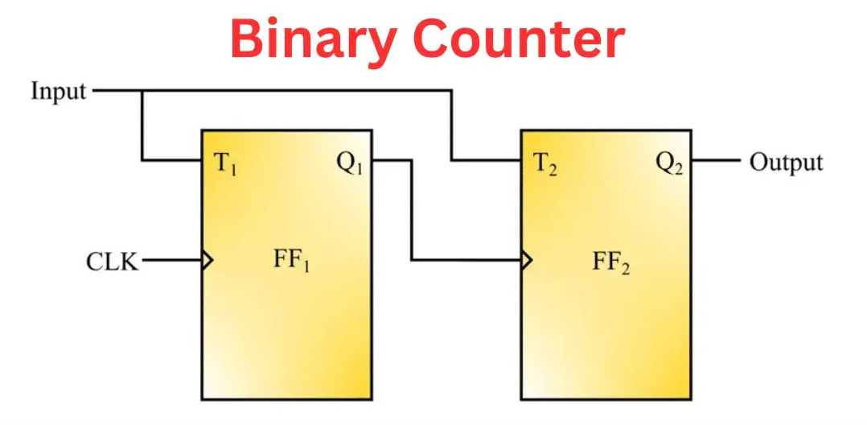
Figure- 3.1: Binary Counter [2].
Binary counter is a digital electronic device that counts, stores, and displays the number of times a specific event has occurred. It is a type of sequential logic circuit. To perform the counting operation, it uses a clock signal. In simple words, a binary counter is an electronic device used in digital systems for counter purposes. Overall, the main purpose of this counter is to count and record the number of an occurrence of a particular input signal. A binary counter can perform counting in a specific range, i.e. 0 to (2^{n} – 1), where, 0 is the first count, while (2^{n} – 1) is the last count limit. The variable `n` represents the total number of bits that the counter can handle.
For example, a 8-bit binary counter has n = 8, and therefore it can count between 0000 0000 (0) and 1111 1111 (255) and then come back to the initial stage, i.e. 0000 0000(0) [3].
In this project, an Up-Down Binary Counter is implemented using the Atmega32 microcontroller. The Atmega32 is a popular 8-bit microcontroller from the AVR family, known for its versatility and ease of use. The counter counts up or down based on the state of two push buttons connected to PD2 and PD3 pins of the microcontroller.

Required Components:
- Atmega32 Microcontroller
- Power
- LEDs – Yellow (8)
- Wire
- Ground-(2)
- Push Button-(2)

Working Principle:
- The data direction register (DDRC) is set to configure PORTC as an output port, while the data direction register for PORTD is configured to set PD2 and PD3 as input pins.

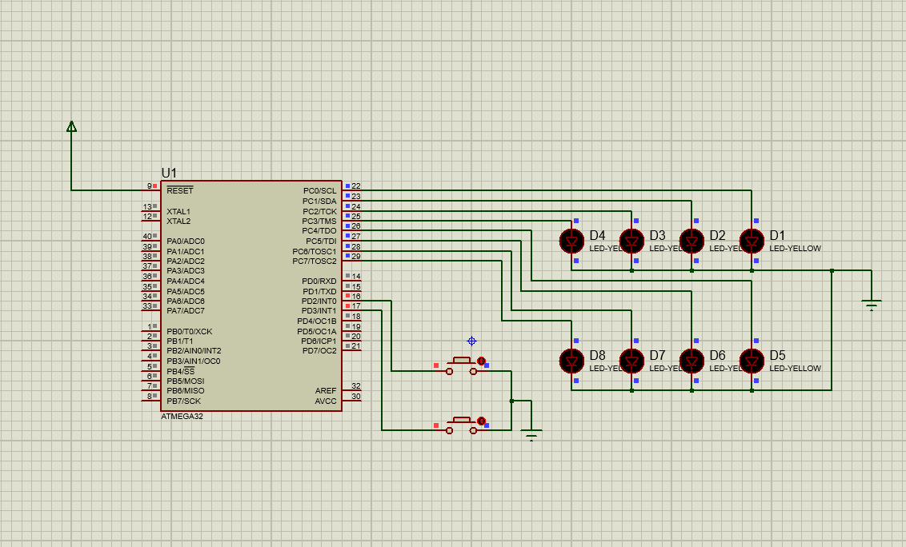
Figure- 3.2(a): Inactive phase of LEDs in simulation
- Pull-up resistors are activated for these input pins to ensure a defined logic level when the switches are open.
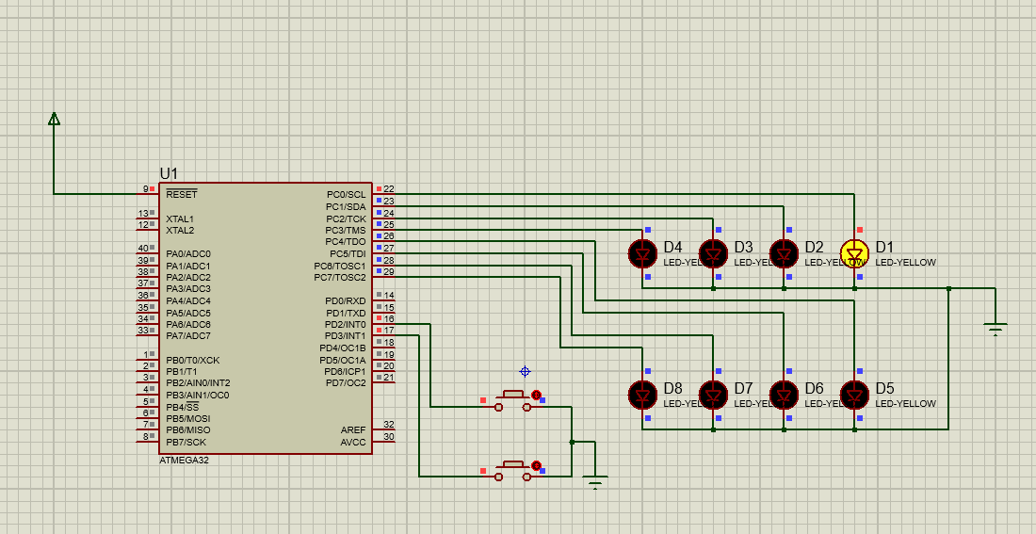
Figure- 3.2(b): Binary Counter circuit active LED (D1 on)
- The program entered a continuous loop where it constantly checked the status of the input pins PD2 and PD3. Upon detecting a low signal on PD2, a debounce delay of 10 milliseconds is applied to filter out switch bouncing.
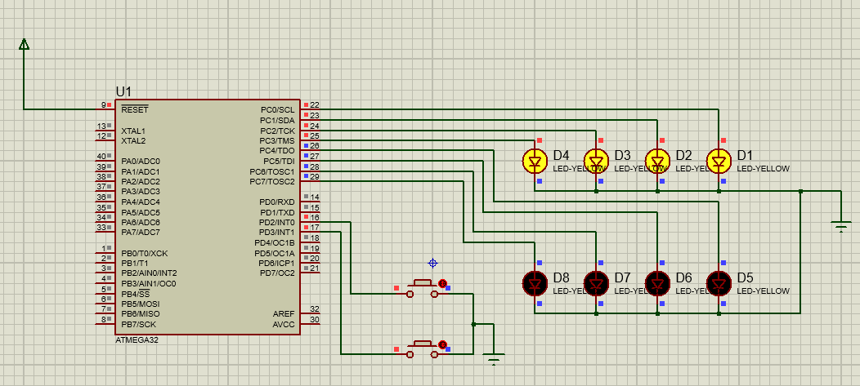
Figure- 3.2(c): Binary Counter circuit active (D1, D2, D3, D4 on)

- If PD2 remained low after the delay, the count is incremented if it is less than 255, and the program waits until PD2 returns to a high logic level.
- Similarly, when a low signal is detected on PD3, a debounce delay of 250 milliseconds is applied.
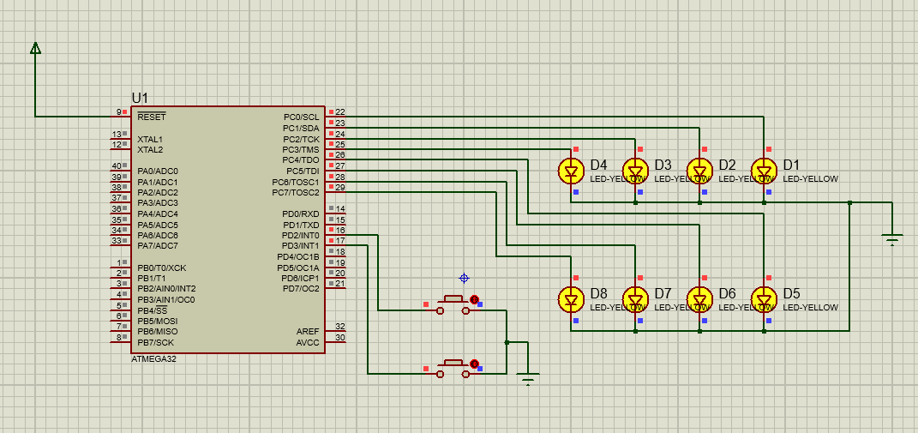
Figure- 3.2(d): Binary Counter circuit active (D1, D2, D3, D4, D5, D6, D7, D7, D8 on)

- If PD3 remained low after the delay, the count is decremented if it is greater than 0, and the program waits until PD3 returns to a high logic level. The current count value is then displayed on PORTC, and a delay of 250 milliseconds is applied before the process repeats.

Code:

#include <avr/io.h>
#include <util/delay.h>
#define F_CPU 8000000UL

int main(void) {

DDRC = 0xFF;
DDRD &= ~(1 << PD2);
DDRD &= ~(1 << PD3);

PORTD |= (1 << PD2) | (1 << PD3);

uint8_t count = 0;

while (1) {

if (!(PIND & (1 << PD2))) {
_delay_ms(10);
if (!(PIND & (1 << PD2))) {
if (count < 255) {
count++;
}

while (!(PIND & (1 << PD2)));
}
}
if (!(PIND & (1 << PD3))) {
_delay_ms(10);

if (!(PIND & (1 << PD3))) {

if (count > 0) {
count--;
}
while (!(PIND & (1 << PD3)));
}
}

PORTC = count;

_delay_ms(100);
}

return 0;
}

Discussion:
In this experiment, the circuit was successfully implemented in Proteus software. The Atmega32 microcontroller accurately controlled. Upon simulation, the binary counter successfully counted up or down based on the input provided by the user through the switches. The counter incremented or decremented by one with each input pulse, and it reset to zero upon reaching the maximum or minimum count.

Practical Uses:
- Traffic Light Control System: Implementing an Up-Down Binary Counter can be used in controlling traffic lights at intersections
- Production Line Monitoring: In manufacturing, the counter can be used to keep track of items produced on a production line
- Smart Energy Management: The binary counter can be employed in smart energy management systems to monitor and control energy consumption in buildings.
- Digital Clock with Alarm: The counter can keep track of hours, minutes, and seconds, incrementing with each second. When the desired alarm time is reached, it triggers an alarm signal.

Conclusion:
The Up-Down Binary Counter using Atmega32 provides a simple and effective way to count up or down based on user input. The code has been successfully implemented to increment and decrement a count variable based on button presses, with the count value displayed on PORTC. The usage of pull-up resistors ensures stable input readings, while the delays prevent rapid count changes due to button bouncing. Overall, the code efficiently achieves its intended functionality for simple input handling and count display on an AVR microcontroller.

References:
[1] Up-down binary counter [Online]. Available:
https://www.google.com/search?client=firefox-b-d&q=binary+counter (2024)

[2] Binary Counter [Online]. Available:
https://www.electricalvolt.com/wp-content/uploads/2023/07/image-22.png?ezimgfmt=ng:webp/ngcb1

[3] Binary Counter [Online]. Available:
https://www.electricalvolt.com/binary-counter-in-digital-electronics/ (2024)

